*DragoFly: Fire and Destruction*

# Overview/Theme

## Idea Summary

Our main player is a dragon. Enemies are army units. Dragon uses firebreath and fireballs to finish enemy units. Army units attack the dragon.

## Goal

What's the ultimate aim of the player playing this game? Why will it be fun, entertaining or satisfying?

Ans: Main goal is flying dragon and causing destruction upon enemies with realistic effects.

# 

# Mock Ups

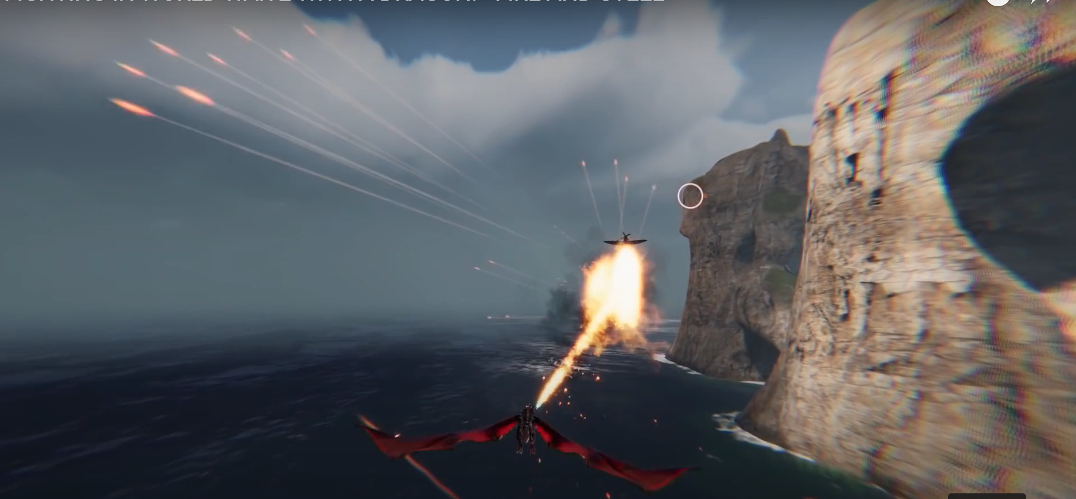

# References (Optional)

https://www.youtube.com/watch?v=t6nzlp4DDLk

# Art Style (check any number of boxes that apply)

* 3D
* High Poly
* Photo Realism

# Look & Feel / Camera

* Third Person

# Mechanic

## Controls

* Landscape
* Joystick
* Tap
* Hold
* Release

# Progression

* Level Based
* Score Based